JDBC Mini Project

Student Academic & Continuous Evaluation System

- By Sharan V – 25ITR134

AIM:
To develop a Student Academic and Continuous Evaluation System for Kongu Engineering College (R2024) using Java JDBC and MySQL to manage student details, course information, enrollment, assessment marks, attendance, internal marks, and final results efficiently.

OBJECTIVE:
- To develop a Java-based application for managing student academic information.
- To store and retrieve student details using a MySQL database.
- To manage course information and student enrollment.
- To record and display assessment marks for students.
- To maintain attendance records and calculate attendance percentages.
- To calculate internal marks based on the assessment data stored in the database.
- To generate final results based on the marks entered into the system.
- To establish database connectivity using Java Database Connectivity (JDBC).
- To reduce manual work and improve the accuracy of academic record management.
- To provide a simple, menu-driven interface for performing academic operations.

FLOWCHART:

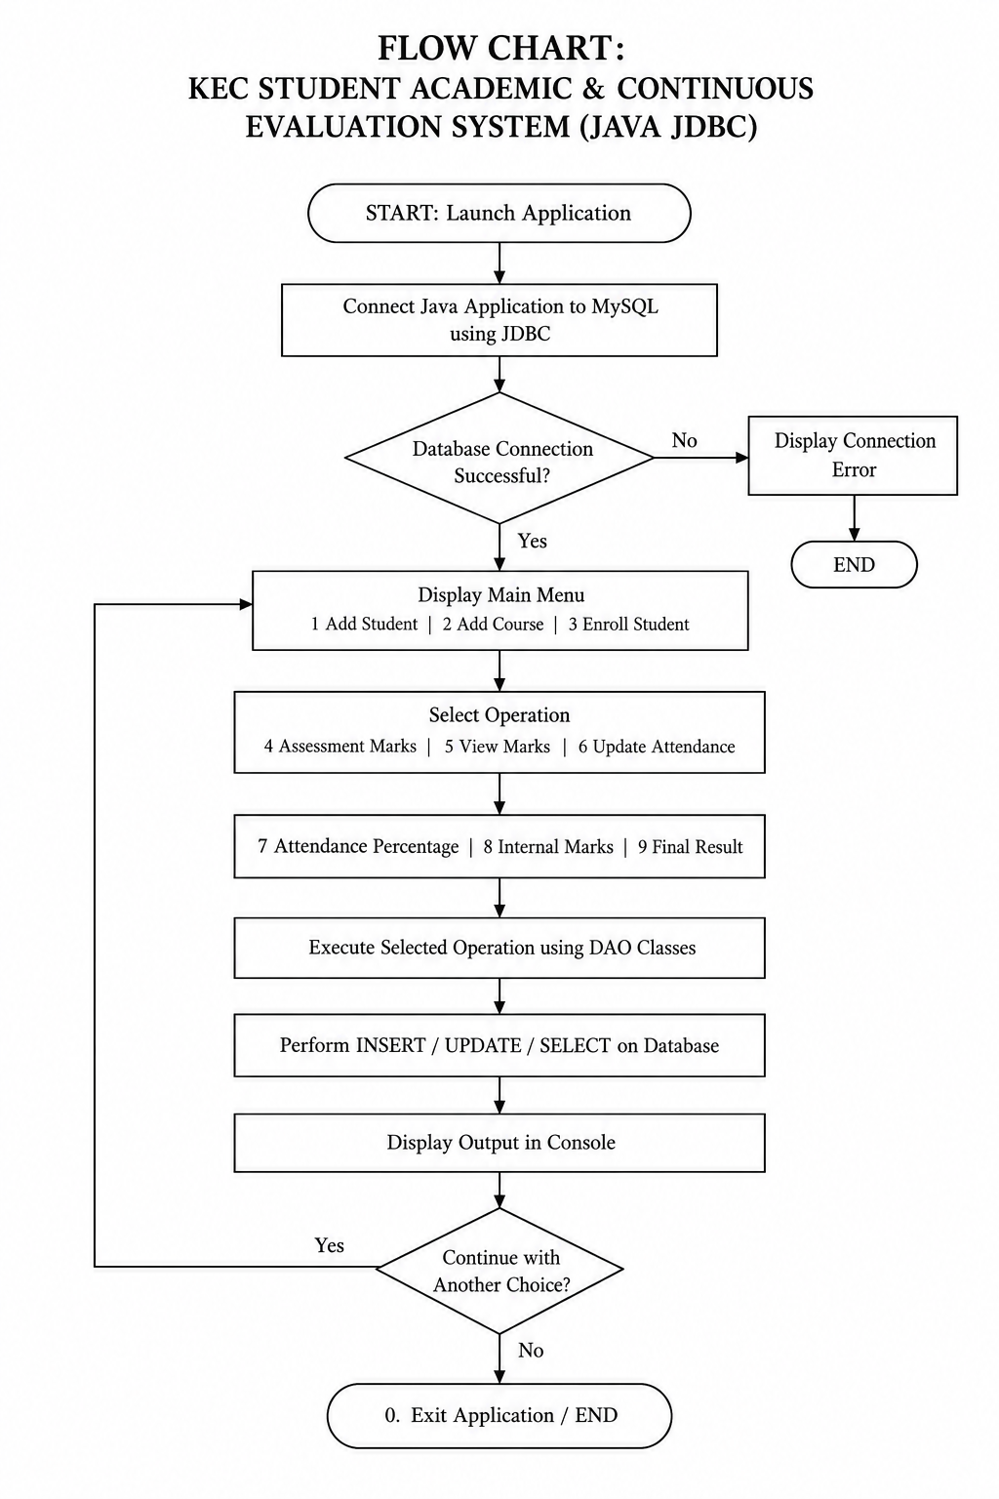

DATABASE SCHEMA:

- STUDENTS TABLE:
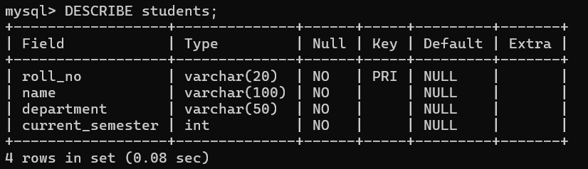

- COURSES TABLE:
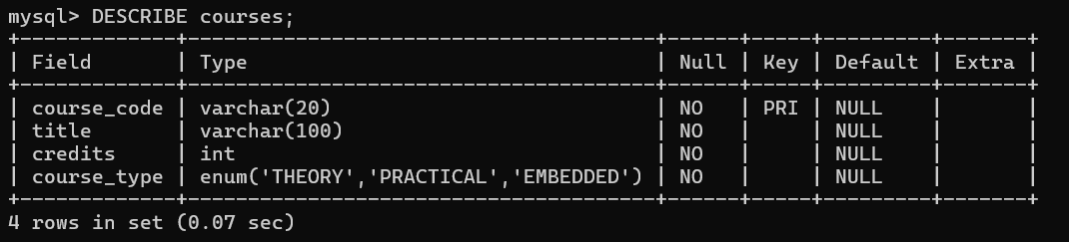

- ENROLLMENTS TABLE:
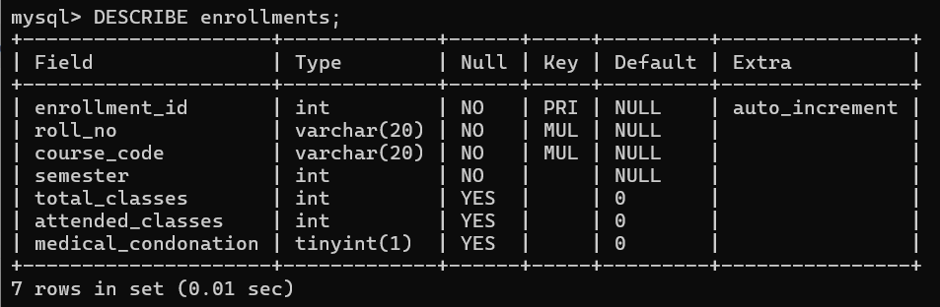

- ASSESSMENT MARKS TABLE:

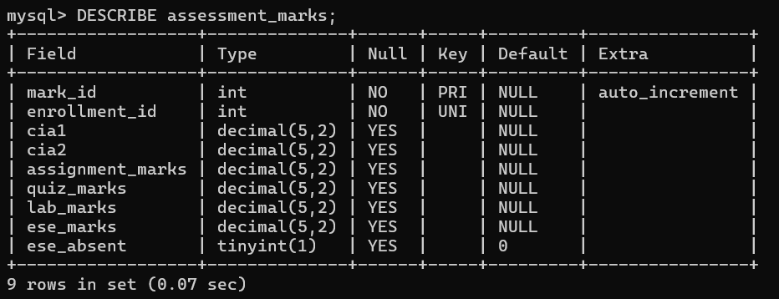

SOURCE CODE:
MainMenu.java :
import java.util.Scanner;
public class MainMenu {
public static void main(String[] args) {
Scanner sc = new Scanner(System.in);
int choice = -1;
do {
System.out.println("\n==================================");
System.out.println(" KEC STUDENT ACADEMIC SYSTEM");
System.out.println("==================================");
System.out.println("1. Add Student");
System.out.println("2. Add Course");
System.out.println("3. Enroll Student");
System.out.println("4. Add Assessment Marks");
System.out.println("5. View Student Marks");
System.out.println("6. Update Attendance");
System.out.println("7. View Attendance Percentage");
System.out.println("8. View Internal Marks");
System.out.println("9. View Final Result");
System.out.println("0. Exit");
System.out.println("==================================");
System.out.print("Enter your choice: ");

try {
choice = Integer.parseInt(sc.nextLine().trim());
} catch (NumberFormatException e) {
System.out.println("Please enter a valid number.");
continue;
}
String className = null;
switch (choice) {
case 1: className = "StudentDAO"; break;
case 2: className = "CourseDAO"; break;
case 3: className = "EnrollmentDAO"; break;
case 4: className = "AssessmentDAO"; break;
case 5: className = "ViewMarksDAO"; break;
case 6: className = "AttendanceDAO"; break;
case 7: className = "AttendancePercentageDAO"; break;
case 8: className = "InternalMarksDAO"; break;
case 9: className = "FinalResultDAO"; break;
case 0:
System.out.println("Thank you!");
break;
default:
System.out.println("Invalid choice.");
}
if (className != null) {
try {
String javaHome = System.getProperty("java.home");
String javaCommand = javaHome + java.io.File.separator
+ "bin" + java.io.File.separator + "java";
String classPath = System.getProperty("java.class.path");
ProcessBuilder pb = new ProcessBuilder(
javaCommand, "-cp", classPath, className);
pb.inheritIO();
Process process = pb.start();
process.waitFor();

} catch (Exception e) {
System.out.println("Unable to run program: "
+ e.getMessage());
}
}

} while (choice != 0);
sc.close();
}
}

DBConnection.java :

import java.sql.Connection;
import java.sql.DriverManager;
import java.sql.SQLException;
public class DBConnection {
private static final String URL =
"jdbc:mysql://localhost:3306/kec_academic";

private static final String USER = "root";
// Replace this with your MySQL root password
private static final String PASSWORD = "YOUR_MYSQL_PASSWORD";
public static Connection getConnection() throws SQLException {
return DriverManager.getConnection(URL, USER, PASSWORD);
}
public static void main(String[] args) {
try (Connection con = getConnection()) {
System.out.println("MySQL Connected Successfully!");
} catch (SQLException e) {
System.out.println("Connection Failed!");
e.printStackTrace();
}
}
}

OUTPUT:

- The output shows the successful addition of student details to the database.
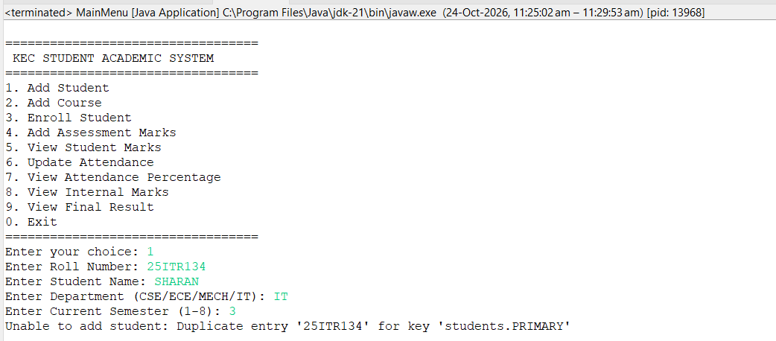

- The output shows the successful addition of course details to the database.
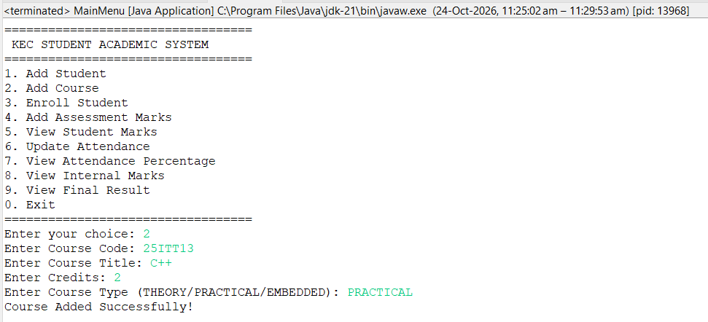

- The output confirms the enrollment of a student in a selected course.
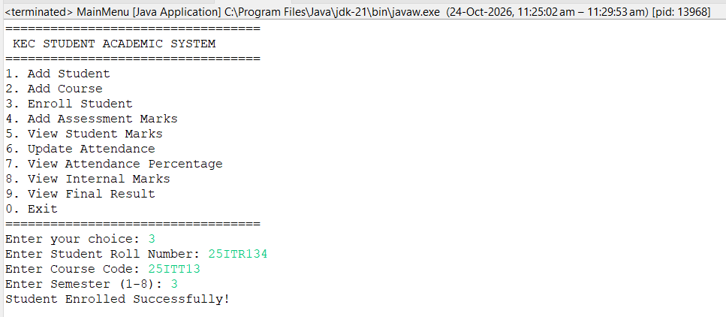

- The output shows the assessment marks entered and stored for a student's course.

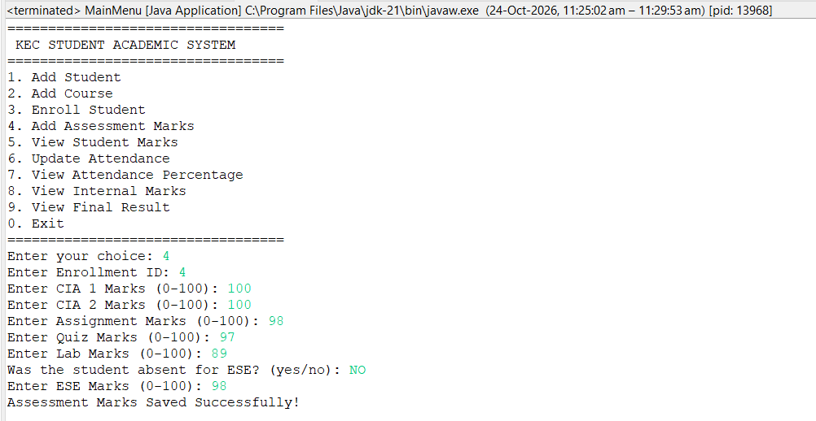

- The output displays the marks obtained by a student in a selected course.

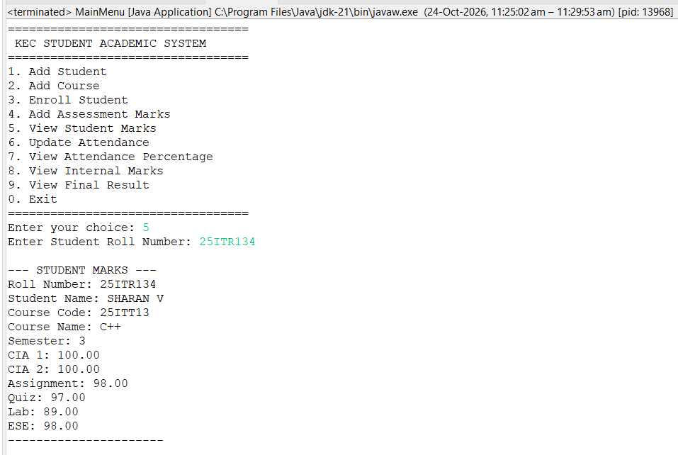

- The output confirms the update of a student's attendance details.

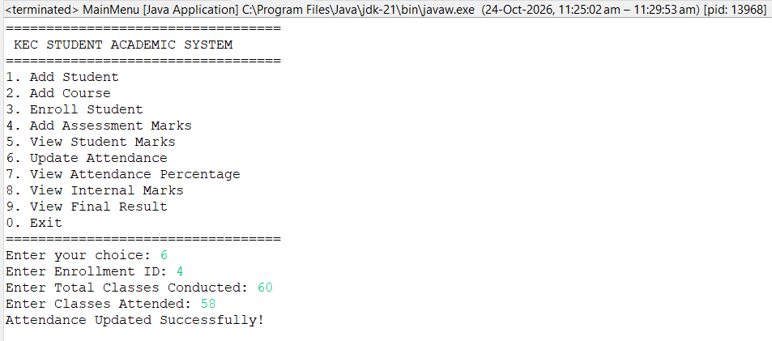

- The output displays the student's calculated attendance percentage.

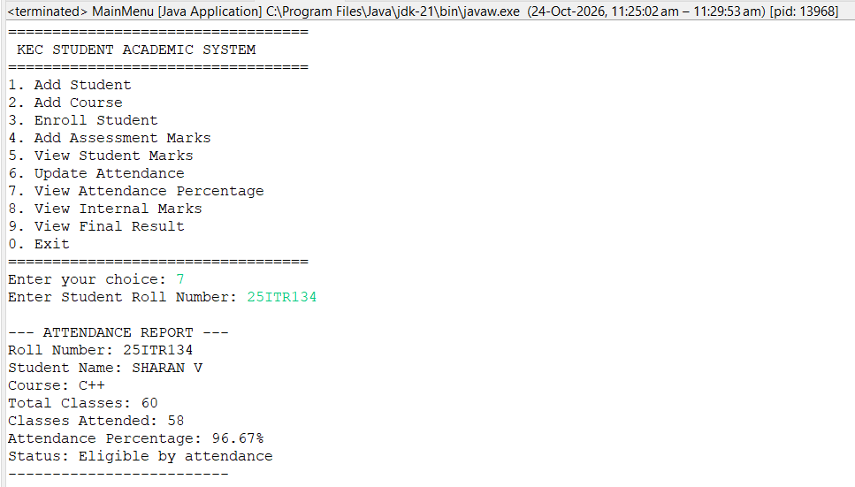

- The output displays the calculated internal assessment marks of a student.
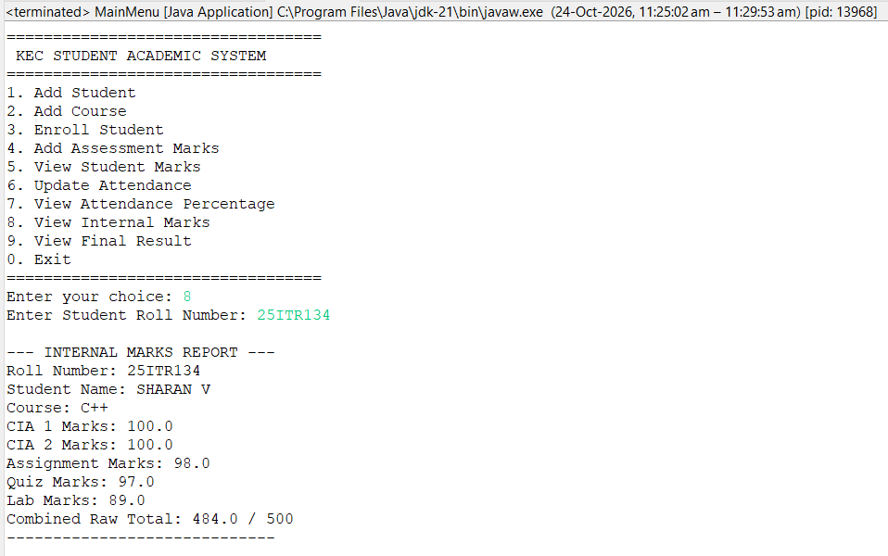
- The output displays the student's final result based on the assessment and examination marks
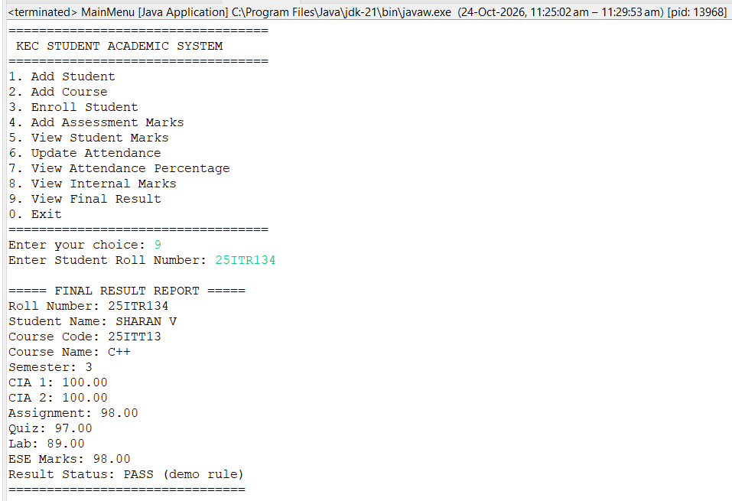

- The output confirms the successful termination of the application.

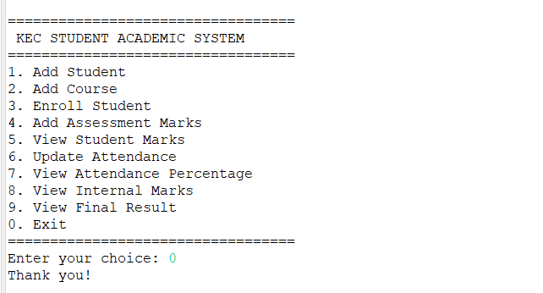

ATTENDANCE & GRADING RULES :
- Attendance Filter :
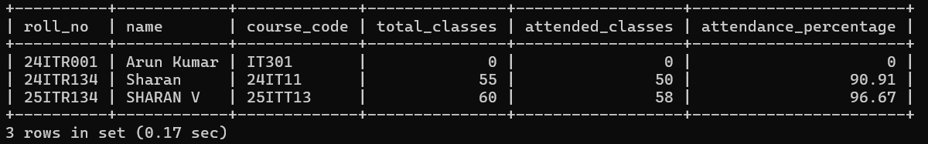
- Student Semester Marksheet :
- Department wise Class Performance & Result Summary :
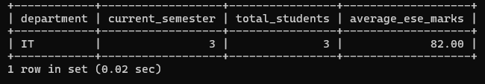

DATABASE :
STUDENTS DATABASE:
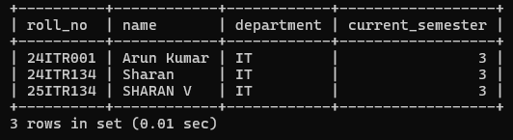
COURSES DATABASE:
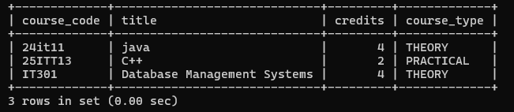
ENROLLMENTS DATABASE:
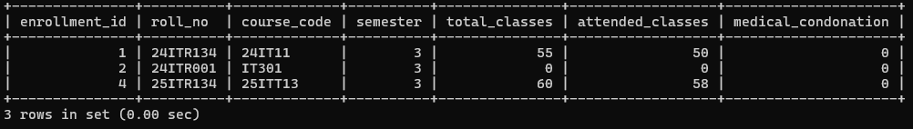

RESULT:
The Student Academic & Continuous Evaluation System was successfully developed using Java JDBC and MySQL. The system manages student details, courses, enrollments, assessment marks, and attendance records. It calculates attendance percentages, internal marks, and final results while displaying academic information through the terminal. Thus, the project simplifies academic record management, reduces manual work, and improves the efficiency of student data handling.

REFERENCES:
- Oracle, Java SE Documentation – JDBC Basics.
https://docs.oracle.com/javase/tutorial/jdbc/
- Oracle, Java SE Documentation – Java Programming Language.
https://docs.oracle.com/en/java/
- Oracle, MySQL 8.0 Reference Manual.
https://dev.mysql.com/doc/refman/8.0/en/
- Oracle, MySQL Connector/J Developer Guide.
https://dev.mysql.com/doc/connector-j/en/
- Oracle, Java JDBC API Documentation.
https://docs.oracle.com/en/java/javase/21/docs/api/java.sql/module-summary.html
- GeeksforGeeks, Establishing JDBC Connection in Java.
https://www.geeksforgeeks.org/establishing-jdbc-connection-in-java/
- W3Schools, SQL Tutorial.
https://www.w3schools.com/sql/
- GitHub, KEC Student Academic & Continuous Evaluation System using Java JDBC – Project Repository.
https://github.com/Sharanv2008-web/JAVA_project1
- Oracle, Java SE Documentation – ProcessBuilder Class.
https://docs.oracle.com/en/java/javase/21/docs/api/java.base/java/lang/ProcessBuilder.html
- OpenAI, ChatGPT – AI Assistant (used for project ideas, explanations, and guidance).
https://chatgpt.com/

GITHUB:
LINK : https://github.com/Sharanv2008-web/JAVA_project1

